Relationship between European powers before the First World War
Data-based question

Name︰_______________ （ ） Class︰__________

Historical skill | Inducing and inferring; Interpreting political cartoons
Related Textbook Content | 2A pp. 11-15

Study the sources below and answer the following questions.

Source A About relations between European countries before World War I
Western powers took part in colonial expansion and fought for smaller countries and regions. They divided spheres of influence and built colonial empires. Among them, Britain had the most colonies. During the late 19th century and the early 20th century, Germany and Britain were in conflicts for colonies. Britain was a naval hegemon, bringing strong security to build and protect such a large empire. Meanwhile, Germany wished to expand its spheres of influences and must fight for maritime supremacy. Before the First World War, hostility between the two sides for maritime hegemony was heated up.

Source B A cartoon published in 1885
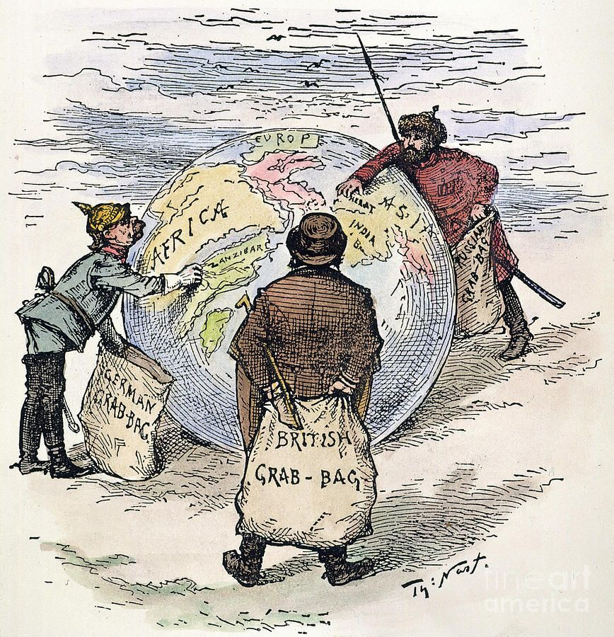
1. According to Source A, identify two countries in conflict before the First World War.
Understand source
________________________________________________________________________

2. Based on the question above, in which aspects did the two countries trigger conflicts in? Analyse source
______________ and ______________ were fighting for ________________ and __________________.

3. What was the main message in the cartoon in Source B? (add ) Analyse source
Anti-extreme nationalism grew in Europe
Reflecting that powers formed rival military alliances
Reflecting that powers scrambled for colonies
Reflecting that poewrs carry out armaments race

4. Before the First World War, were relations among European countries friendly? Cite one clue each from Source A and B to support your answer. Analyse source
________________________________________________________________________
________________________________________________________________________

Answers

1. Germany and Britain.

2. ____Germany_____ and _____ Britain___ were fighting for _____ colonies____ and ____ maritime supremacy___.

3.
Anti-extreme nationalism grew in Europe
Reflecting that powers formed rival military alliances
Reflecting that powers scrambled for colonies
Reflecting that poewrs carry out armaments race

4. Not friendly. According to Source A, During the late 19th century and the early 20th century, Germany and Britain were in conflicts for colonies and maritime supremacy, while Source B depicted a scramble for colonies among Germany, Britain and Russia. This shows that it was common for European countries to fight for colonial expansion, which turned relations to tense.

